VFW KEN Chapman Post 12074 is proud to share a piece of history on one of our charter members, our namesake and a true Vietnam Veteran Hero, WO1 Kenneth Robert Chapman.

Kenneth Robert Chapman was born on 17 August 1939. After graduation from high school, he

served for eight years as an enlisted soldier, serving overseas in France and Germany. Chapman

volunteered for helicopter training, and upon graduation from flight school, was appointed as a

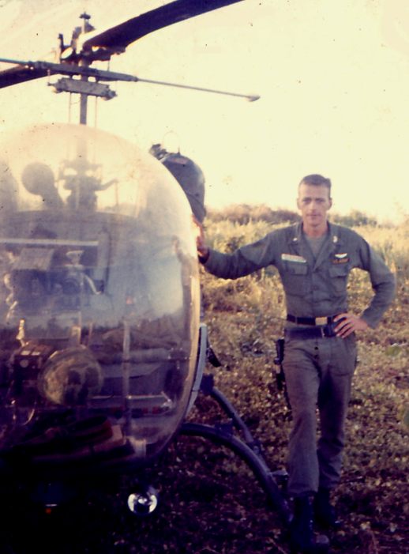Warrant Officer. He served 15 months flying

helicopters in Vietnam in the First Cavalry Division.

WO1 Ken Chapman was awarded the Distinguished

Flying Cross for his actions on 12 October 1965

during Operation SHINY BAYONET (10‐14 October

1965). The First Cavalry Division official history of

the Vietnam War described the operation as

follows:

“On 10 October 1965, in Operation SHINY

BAYONET, the First Team initiated their first

brigade‐size airmobile action against elements

of the NVA 325th Infantry (Song Lo) Division

located in the Soui Ca River Valley about 275

miles northeast of Saigon, near An Khe in Binh

Dinh Province. Special agents and ARVN sources

had located the base camp of two battalions of the Viet Cong 2nd Main Force Regiment.

Operation SHINY BAYONET called for the ARVN 22nd Division to make initial contact and drive

the VC toward the elements of the 3rd Brigade, 1st Cavalry Division who were deployed as a

blocking force.”**1**

Later that day, a CBS news crew flew into the battle zone on a medical evacuation helicopter,

which was shot down on approach. A young reporter named Morley Safer filed the video report

called *Baptism of Fire,”***2** which shows the challenges of evacuating the first casualties that 1st

Battalion, 12th Cavalry Regiment took on the opening day of Operation SHINY BAYONET.

For More on WO1 Chapman [CLICK HERE](https://vfw12074.org/uploads/Documents/Newkirk%20and%20Chapman%20Bio%20Pages/PostHistoryChapmanFinalEdit-1.pdf).

1 1st Cavalry Division History, Vietnam War, 1965‐1972, http://www.firstteam.us/tableaux/chapt_08/, on 14 December 2020

**2** https:/www.cbsnews.com/news/baptism‐of‐fire